Yurii Hehediush
Instructor: Nandhini Gulasingam
DSC 323
Project Proposal
May 13, 2024

- Dataset name: Seoul Bike Sharing Demand.
- Source of the dataset: D2L (provided by the instructor.)
- Brief overview of chosen dataset: Since the number of variables exits screenshot visibility it was split into two screenshots.
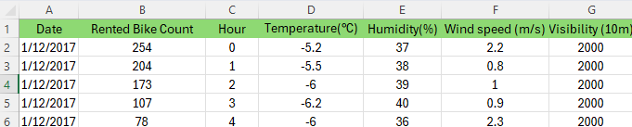 continue...
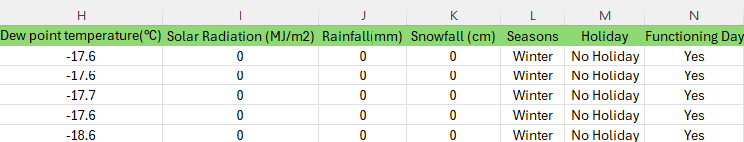
- For the current data set the Dependent Variable is “Rented Bike Count.”
- There are 13 Independent Variables. The full list IV: “Date, Hour, Temperature (C), Humidity (%), Wind speed (m/s), Visibility (10m), Dew point temperature (C), Solar Radiation (Mj/m2), Rainfall (mm), Snowfall (cm), Seasons, Holiday, Functioning Day.”
- The total number of observations is 8760. The detailed analysis showed that there are no missing values in the data.
- Timeline:
Week 6: Data research; analysis and observation; data cleaning. Begin exploratory data analysis to understand variable distributions and identify potential outliers or anomalies.
Week 7: Detailed investigation of chosen data. The beginning of writing SAS code exploring data visualization and different variables. Start formulating hypotheses and examining initial relationships between variables.
Week 8: The beginning of initial regression models and testing for basic assumptions. Test assumptions of normality, linearity, homoscedasticity, and independence of residuals in regression models.
Week 9: Analyzing SAS code/output. Refining models. Check for multicollinearity using variance inflation factor (VIF) or correlation matrices, adjusting models based on these insights. Consider transformations or interaction terms to improve model fit.
Week 10: Focus on finalizing the model. Validating the data by using SAS output and preparing for presentation. Using the Train-Test Split/ Cross Validation methods to check model’s predictive accuracy.
Week 11: Building the final report. Combining all the the results/output from data and adding to the appendix. Ensure interpretation of the model results is clear and contextually relevant. Reviewing all details: double testing SAS code, models, hypotheses, and other important aspects. After polishing, submit the final project.

